**Assignment No 4**

**Name Muhammad Ali**

**Sid 9363**

**Cid 102326**

Design a ring network which consist of five router use the network address which have been assigned in lab session apply floating route on this network

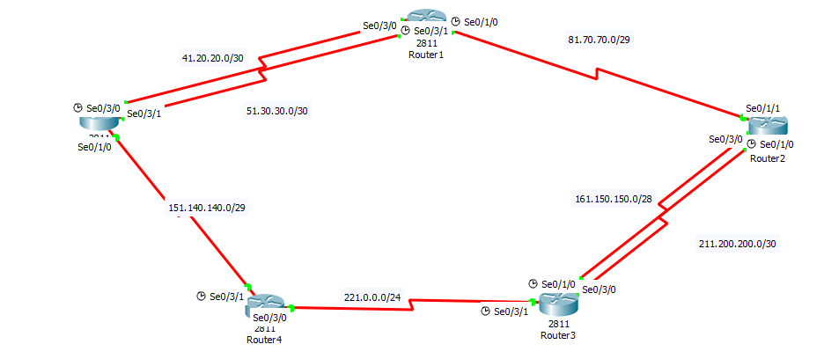

Router 0 Configuration: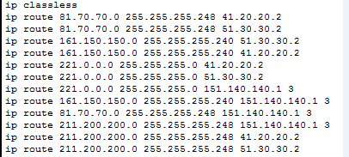

Router 1 Configuration:

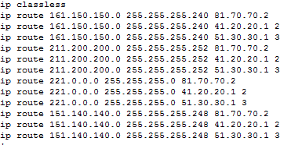  
Router 2 Configuration:

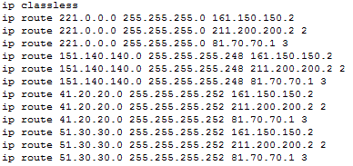

Router 3 Configuration:

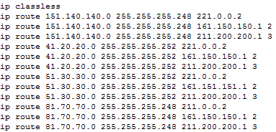

Router 4 Configuration:

